**Quantitative Biology Lab – April 15, 2022**

**1.** For the first-order reaction A 🡪 C, derive an expression for [C] (as a function of time), using the equations given in class.

See below:

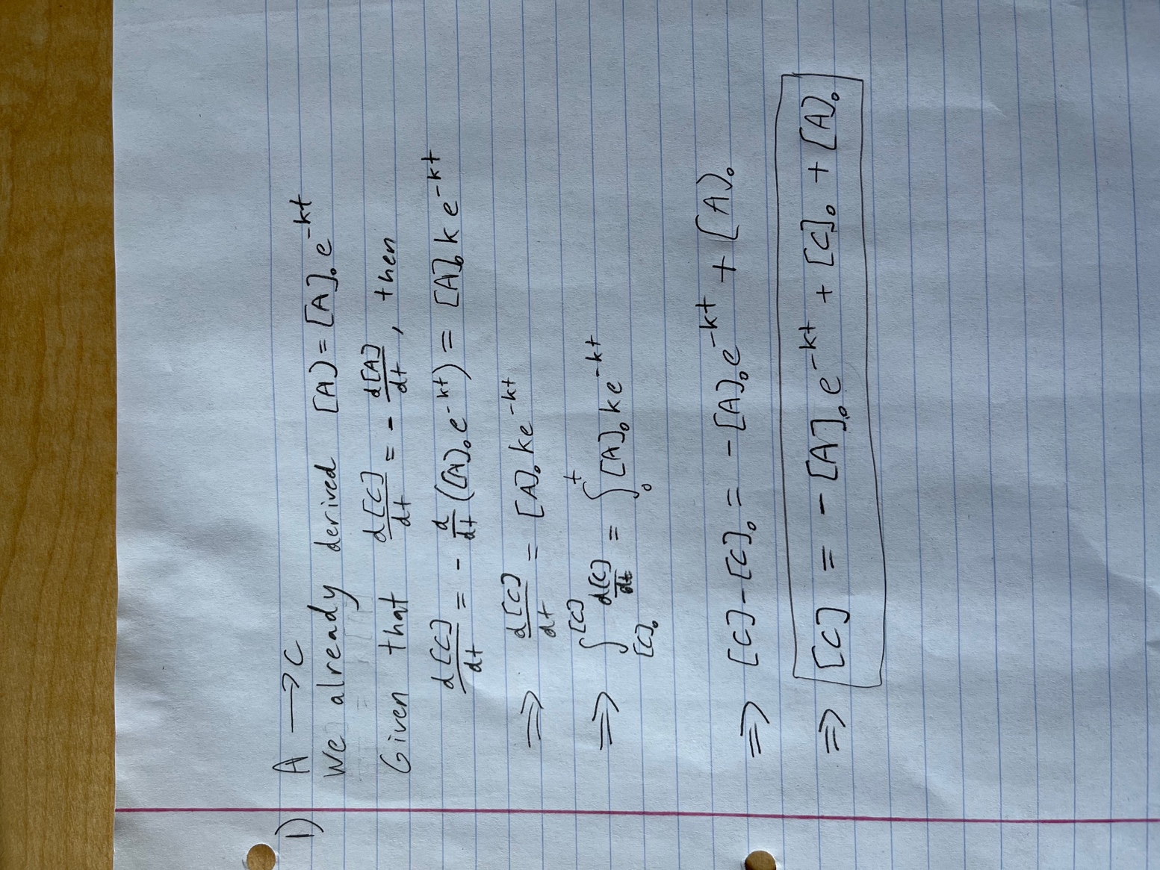

**2.** Consider the following zero-, first-, and second-order reactions:

zero-order: $A+Z →A∙Z →C+Z$

first-order: $A→C$

second-order: $A+B→C (with {\left[A\right]}_{0}={\left[B\right]}_{0})$

1. What are the units for the rate constants and for the half-lives for these three reactions?

Rate constants:  
Zero order: M/s

First order: 1/s

Second order: 1/(Ms)

Half-lives:

The units are seconds for all three reactions.

1. Using Python, create plots of the concentration of A ([A]) vs. time (0 ≤ t ≤ 10) for these reactions in one figure, using values of the starting concentration ([A]0) and t1/2 equal to one. Be sure to label the axes and add a legend that identifies the individual plots.
2. What fraction of the reactant A has been converted into product for each of the reactions at the following time points?  
    i. t = 0.5 * t1/2  
    Zero order: 0.75

First order: 0.707

Second order: 0.667

ii. t = 1 * t1/2  
 0.5 for all

1. iii. t = 2 * t1/2  
   Zero order: 0

First order: 0.25

Second order: 0.333

1. iv. t = 10 * t1/2  
    Zero order: 0

First order: 9.77x10-4

Second order: 0.091

**3.** The file ‘A_vs_t.txt’ contains simulated data from a kinetic measurement. Column 1 contains time values, column 2 contains measured signal values. The measured signal is proportional to the concentration of A.

The provided Python script fits the data to a zero-order kinetic model and plots the data with the fit as well as the residuals (figures below).

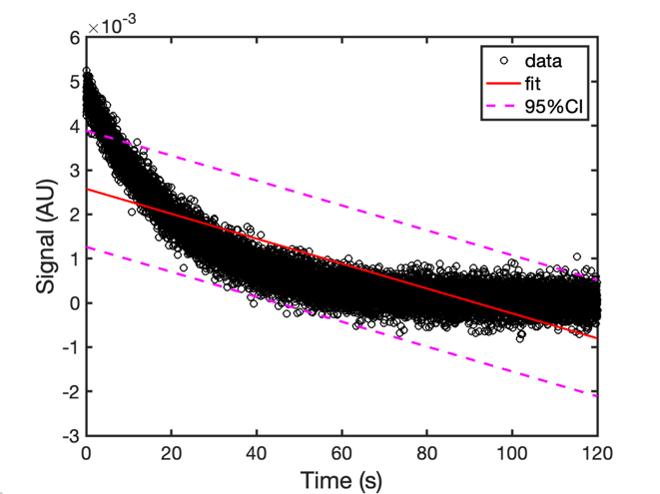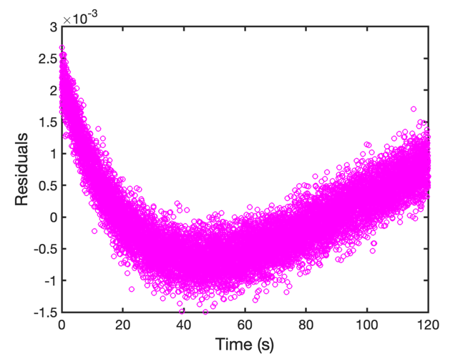

* 1. Fit the data to the first- and second-order models described in Q2. Use the Python script provided and adjust it as necessary to do the first- and second-order model fitting.
  2. Which of the three models (zero-, first- or second-order) best describes the input data? Why? What is the rate constant (with units)?

First-order fits best because it has the most uniform residuals, and the maximum absolute value residual is smaller than it is for either zero- or second-order reactions. Additionally, the first-order reaction has the lowest sum of the square of the residuals of all three models.